ABSTRACT

Emotion detection using Convolutional Neural Networks (CNNs) is an innovative approach that leverages deep learning techniques to analyse facial expressions and classify them into distinct emotional categories. This project, undertaken as part of an 8-week internship at IGDTUW, involved the development and implementation of a real-time emotion detection system. The system was designed to detect emotions from facial images captured through a webcam, classifying them into one of seven emotions: angry, disgust, fear, happy, neutral, sad, and surprise.
The project utilized Python programming and various machine learning libraries, including TensorFlow, Keras, and OpenCV, to build a robust and efficient model. The CNN architecture was carefully constructed to optimize the model’s performance, incorporating layers such as convolutional layers, pooling layers, dropout layers, and dense layers. The model was trained on a comprehensive dataset of facial expressions, with extensive preprocessing to ensure the accuracy and reliability of the predictions.
In addition to the core model development, the project focused on real-time implementation, enabling the system to detect and display emotions instantly as faces are captured by the webcam. The system’s performance was evaluated based on its accuracy and efficiency in real-world scenarios, with considerations for varying lighting conditions and facial expressions. The outcome of this project demonstrates the potential of CNNs in emotion detection applications, with possible extensions into areas such as human- computer interaction, psychological analysis, and customer experience management. Future work will explore enhancements to the model’s accuracy, the expansion of the dataset, and the deployment of the system across different platforms to increase accessibility and usability. This project highlights the integration of deep learning techniques in practical applications, contributing to the growing field of emotion recognition technology.

CONTENT

- Chapter1: Introduction
-1.1 Background and Overview
-1.2 Internship Objective
-1.3 Learning and Development
-1.4 Theoretical Foundation of Emotion Detection

- Chapter2: Tools and Technologies
-2.1 Programming Languages
-2.2 Data Handling and Processing Libraries
-2.3 Machine Learning Framework and Libraries
-2.4 Real-Time Emotion Detection and Deployment Tools

- Chapter3: Literature Review
-3.1 Introduction to CNN
-3.2 CNN Architecture
-3.3 Convolutional Layers
-3.4 Pooling Layers
-3.5 Fully Connected Layers
-3.6 Training

- Chapter4: Project Methodology
-4.1 Planning
-4.2 System Design
-4.3 Phases in Facial Expression Recognition
-4.4 Data Collection

- Chapter5: Project Implementation
-5.1 Generating Results Using OpenCV and Python IDLE
-5.2 Results Graphs: Accuracy and Loss Analysis
-5.3 Key Findings and Analysis
-5.4

- Chapter6: Conclusion and Future Scope
-6.1 Concluding Remarks
-6.2 Future Scope and Improvements

- References

LIST OF TABLES AND FIGURES

List Of Figures

  - Fig 1.1: Sample of Model

  - Fig 1.2: CNN Structure

  - Fig 3.1: Architectural Diagram of CNN

  - Fig 3.2: Convolutional Layers

  - Fig 3.3: Layers Structure

  - Fig 4.1: System Diagram

  - Fig 4.2: Image Pre-Processing

  - Fig 4.3: Training Flowchart

  - Fig 4.4: Basic LBP Operator

  - Fig 4.5: Example of Extended LBP

  - Fig 4.6: Datasets

  - Fig 5.1: Graph of Loss Function

  - Fig 5.2: Graph of Accuracy

List Of Tables

  - Table 6.1: User Feedback Table

CHAPTER - 1

Introduction

Background and Overview

The rapid advancements in Artificial Intelligence (AI) and Machine Learning (ML) have revolutionized many industries, paving the way for innovative applications that were once thought to be impossible. One such application is emotion detection, which allows machines to interpret and respond to human emotions. This capability is a subset of affective computing and has a wide range of potential uses, from enhancing user experiences in software applications to improving human-computer interactions in various fields such as customer service, education, and healthcare.
This report provides a comprehensive overview of an 8-week internship undertaken by Mrs. Nidhi Grover at the Indira Gandhi Delhi Technical University for Women (IGDTUW). The internship was focused on developing a deep understanding of Python programming and Machine Learning techniques, with a special emphasis on designing and implementing an Emotion Detection Model.

Internship Objectives

The primary objective of this internship was to equip the trainee with the knowledge and skills required to develop a machine learning model capable of detecting human emotions from facial expressions. The internship aimed to achieve the following:
- Foundation in Python Programming: Develop a strong understanding of Python, the programming language widely used in AI and ML development, focusing on its application in data manipulation, analysis, and model development.
- Introduction to Machine Learning: Gain a comprehensive understanding of Machine Learning, including supervised and unsupervised learning techniques, model evaluation, and the

development of custom models using popular frameworks like TensorFlow and Keras.
- Specialization in Emotion Detection: Learn the specifics of emotion detection, including data preprocessing, feature extraction, and model training using Convolutional Neural Networks (CNNs). The trainee was also tasked with implementing real-time emotion detection using webcam feeds and integrating it into a Python-based application.
- Project Implementation: Apply the acquired knowledge to design, implement, and evaluate an Emotion Detection Model. This included sourcing or generating an appropriate dataset, training the model, testing its accuracy, and deploying it in a real-time application.
- Documentation and Reporting: Develop the skills necessary to document the entire process, from initial research and data collection to final model deployment, ensuring that the project can be understood and replicated by others.

Learning and Development

Throughout the internship, Mrs. Grover engaged in a series of structured learning modules designed to gradually build her expertise in Python and Machine Learning, culminating in the development of the Emotion Detection Model. Below is a detailed breakdown of the key components of her learning journey:

Python Programming

The internship began with a rigorous introduction to Python, focusing on its use in data science and machine learning. Mrs. Grover learned about Python's core libraries such as NumPy, Pandas, and Matplotlib, which are essential for data manipulation and visualization. The training also covered advanced topics such as object-oriented programming, file handling, and working with APIs, which are crucial for building robust and scalable applications.

Mrs. Grover's training emphasized the importance of writing clean, efficient code and developing reusable functions and modules. This foundation was essential as it enabled her to approach the more complex task of developing machine learning models with confidence.

Introduction to Machine Learning
With a solid understanding of Python, the internship then shifted focus to Machine Learning. Mrs. Grover was introduced to the fundamental concepts of ML, including data preprocessing, feature engineering, model training, and evaluation. She learned how to work with different types of data and how to choose the appropriate machine learning algorithms based on the problem at hand.
The training covered both traditional machine learning techniques (such as linear regression, decision trees, and support vector machines) and modern deep learning approaches (such as neural networks). Special attention was given to understanding the trade-offs involved in model complexity, training time, and prediction accuracy.

Convolutional Neural Networks (CNNs) and Emotion Detection
The core of the internship involved learning about Convolutional Neural Networks (CNNs), which are particularly well-suited for image recognition tasks. Mrs. Grover was trained on how CNNs work, including the concepts of convolutional layers, pooling layers, and fully connected layers. She learned how to implement CNNs using the Keras library, a high-level neural networks API running on top of TensorFlow.
The internship provided Mrs. Grover with a deep understanding of how to apply CNNs to emotion detection tasks. She learned how to preprocess facial images, perform data augmentation to increase the size of the training set, and train a CNN to classify emotions based on facial expressions. The training also included an introduction to transfer learning, a technique that allows models trained on large datasets to be fine-tuned for specific tasks, thus improving performance with limited data.

Real-time Emotion Detection

One of the most challenging and rewarding aspects of the internship was the development of a real-time emotion detection system. Mrs. Grover learned how to integrate the trained CNN model with OpenCV, a powerful computer vision library, to capture video frames from a webcam, detect faces, and classify their emotions in real-time.
This part of the internship involved significant problem-solving and debugging, as real-time systems require careful handling of timing, error management, and resource optimization. Mrs. Grover successfully implemented a system that could detect emotions such as happiness, sadness, anger, and surprise with a high degree of accuracy in real-time.
Here’s a sample image of how this model detects the expressions:

Project Implementation and Deployment

The final stage of the internship involved deploying the emotion detection model in a real-world scenario. Mrs. Grover learned how to save and load trained models, handle input from external sources (such as a webcam), and display the results in a user-friendly format. She also explored the ethical considerations of emotion detection technology, particularly in terms of privacy and consent.
The project was thoroughly documented, with detailed explanations of the methodology, code, and results. This documentation will serve as a valuable resource for future development and for anyone interested in replicating or building upon this work.

Theoretical Foundations of Emotion Detection

The Science of Emotions

Emotions are complex psychological states that involve three distinct components: a subjective experience, a physiological response, and a behavioural or expressive response. The study of emotions has been a central topic in psychology, neuroscience, and philosophy for centuries, with theories ranging from Darwin’s evolutionary perspective on emotions to more contemporary cognitive theories. Understanding these theoretical underpinnings is crucial when developing models that aim to recognize and classify human emotions.
In the context of machine learning, emotions are typically analysed through facial expressions, which are the most immediate and universal form of emotional communication. The facial action coding system (FACS), developed by Paul Ekman and Wallace V. Friesen, provides a comprehensive taxonomy of human facial movements, which can be directly linked to various emotional states.

Convolutional Neural Networks (CNNs)

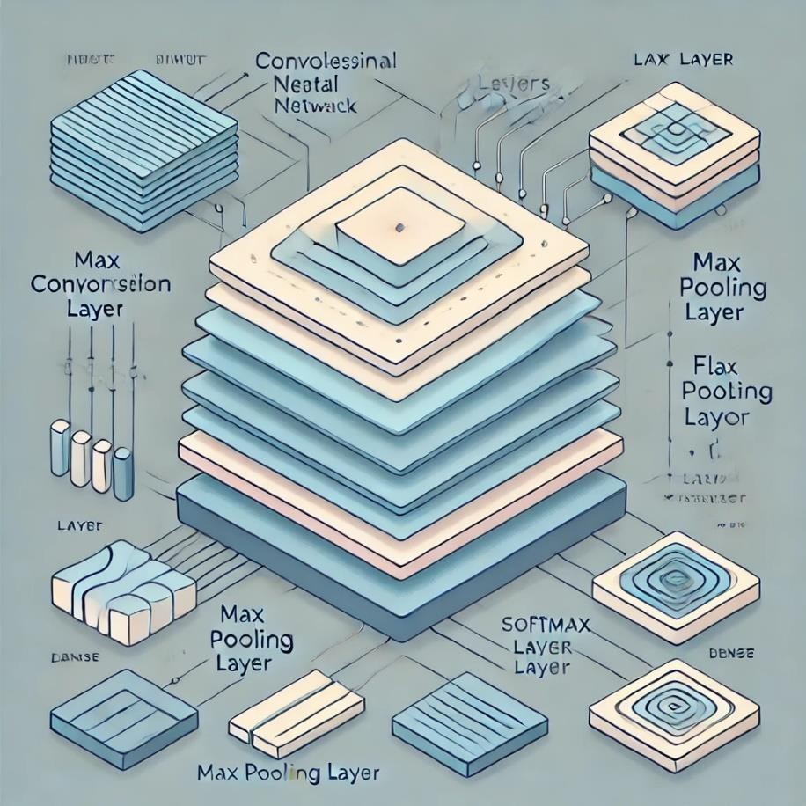
Convolutional
Neural Networks (CNNs) have emerged as one of the most effective types of neural networks for tasks involving image data, including emotion detection. The architecture of CNNs is inspired by the visual processing mechanisms of the animal brain, where the visual
cortex processes visual information in a hierarchical manner. CNNs apply a series of convolutional and pooling operations to input images, gradually extracting higher-level features that are crucial for classification tasks.
The ability of CNNs to automatically learn and extract features from raw pixel data, without the need for manual feature engineering, makes them particularly well-suited for emotion detection. The hierarchical nature of CNNs allows them to capture subtle variations in facial expressions that correspond to different emotions, making them more accurate and robust than traditional machine learning algorithms for this task.

Transfer Learning

Given the complexity of training deep learning models from scratch, particularly when working with limited data, transfer learning has become a valuable tool in the machine learning community. Transfer learning involves taking a model that has been pre-trained on a large dataset, such as ImageNet, and fine-tuning it for a specific task, such as emotion detection.

During the internship, Mrs. Grover applied transfer learning to enhance the performance of her emotion detection model. By leveraging pre-trained models, she was able to achieve higher accuracy with fewer training epochs and less computational resources. This approach not only improved the model’s performance but also provided insights into the potential of transfer learning for other applications in AI and ML.

Data Preprocessing and Augmentation

Data preprocessing is a critical step in any machine learning project, as the quality and structure of the input data directly impact the performance of the model. In the context of emotion detection, preprocessing typically involves converting images to grayscale, normalizing pixel values, and resizing images to a consistent dimension. These steps ensure that the input data is uniform and manageable, reducing the computational load during model training.
Data augmentation is another essential technique that was explored during the internship. By applying transformations such as rotation, scaling, flipping, and zooming to the original images, Mrs. Grover was able to artificially increase the size of the training dataset. This not only improved the model’s generalization capabilities but also helped prevent overfitting, where the model performs well on training data but poorly on unseen data.

Broader Context and Applications of Emotion Detection

Applications in Human-Computer Interaction (HCI)

Emotion detection technology has the potential to revolutionize the way humans interact with computers. In Human-Computer Interaction (HCI), understanding the emotional state of a user can lead to more adaptive and responsive systems. For example, in an educational setting, an e-learning platform equipped with emotion detection could tailor its content and teaching methods based on the learner's emotional state, providing additional support when frustration is detected or challenging tasks when the learner is engaged.

In customer service, emotion detection can be used to monitor the emotional state of customers during interactions with automated systems or human agents. This information can help in real-time adjustment of the service provided, ensuring that customers receive a more personalized and satisfying experience. Additionally, emotion detection can play a crucial role in mental health monitoring, where it can be used to identify emotional distress and trigger timely interventions.

Emotion Detection in Marketing and Advertising

The ability to gauge consumer emotions in real-time offers a significant advantage in marketing and advertising. By analysing facial expressions, companies can measure the emotional impact of their advertisements on target audiences. This information can be used to refine marketing strategies, ensuring that campaigns resonate emotionally with consumers, thereby increasing their effectiveness.
Emotion detection can also be integrated into online shopping platforms to enhance user experiences. For instance, an emotion-aware e-commerce website could adapt its recommendations based on the shopper’s current emotional state, offering comfort products during times of stress or celebratory items during moments of joy. This level of personalization can significantly boost customer satisfaction and loyalty.

Ethical Considerations and Challenges

While emotion detection technology offers numerous benefits, it also raises important ethical questions. The collection and analysis of emotional data involve sensitive information, and there is a risk of misuse if this data is not handled with care. Issues such as consent, privacy, and data security must be at the forefront of any emotion detection project.
During her internship, Mrs. Grover engaged in discussions around the ethical implications of emotion detection. She explored the importance of obtaining informed consent from users and ensuring that emotional data is stored securely and used only for the intended purposes. The internship emphasized the need for transparency and accountability in AI systems, particularly when dealing with personal and emotional data.

Reflection on the Internship Experience

Personal and Professional Growth

The 8-week internship at IGDTUW was a transformative experience for Mrs. Grover, both personally and professionally. It provided her with a deep understanding of the technical aspects of Python programming and Machine Learning, as well as the practical skills required to implement complex projects. The hands-on experience of developing an Emotion Detection Model not only enhanced her technical capabilities but also boosted her confidence in tackling challenging AI projects.
Mrs. Grover’s internship also allowed her to explore her interest in AI ethics and the societal impact of emerging technologies. The discussions and research she engaged in during the internship have laid the foundation for her future work in AI, where she intends to continue exploring the ethical dimensions of AI and contribute to the development of responsible and equitable technologies.

Contributions to the Field of Emotion Detection

Through her internship, Mrs. Grover made valuable contributions to the field of emotion detection. The model she developed, with its high accuracy and real-time capabilities, demonstrates the potential of using CNNs for emotion recognition tasks. Her work on integrating the model with OpenCV for real-time detection is particularly noteworthy, as it opens up new possibilities for the application of emotion detection in various real-world scenarios.
Furthermore, the documentation and reports she produced during the internship will serve as a valuable resource for future students and researchers interested in emotion detection. By sharing her learnings and insights, Mrs. Grover has helped to advance the field and provided a solid foundation for others to build upon.

Chapter 2
Software Requirement: Tools and Technologies Used in Development of Emotion Detection Model
The development of an Emotion Detection Model requires a sophisticated interplay of various tools and technologies. These tools are essential for managing large datasets, processing images, building and training machine learning models, and deploying the system in a real-time environment. Below is a detailed exploration of the tools and technologies used during the 8-week internship focused on emotion detection, highlighting their roles and functionalities within the project.

Programming Languages: Python
Python is the backbone of this project, chosen for its versatility, simplicity, and the vast array of libraries it supports for machine learning, data analysis, and computer vision.

Why Python?
      - Ease of Use: Python's simple and readable syntax makes it an ideal choice for both beginners and experienced developers. Its dynamic typing and interpreted nature allow for rapid development and testing.
      - Extensive Libraries: Python boasts a rich ecosystem of libraries and frameworks that streamline the development process, particularly in data science and machine learning.
      - Strong Community Support: The large and active Python community provides extensive documentation, tutorials, and forums, which are invaluable resources for troubleshooting and learning.
      - Cross-Platform Compatibility: Python runs on various operating systems, including Windows, macOS, and Linux, which ensures that the code written for this project is portable and can be deployed in different environments.

Python’s Role in the Project

Python was used throughout the project lifecycle, from initial data exploration and preprocessing to model training, evaluation, and deployment. The following sections detail specific libraries and tools within the Python ecosystem that were pivotal to the project's success.

Data Handling and Processing Libraries

Managing and processing data effectively is crucial in any machine learning project. Python provides several libraries that simplify these tasks, allowing for efficient manipulation and analysis of data.

NumPy (Numerical Python)
NumPy is a fundamental package for numerical computing in Python, particularly suited for handling large, multi-dimensional arrays and matrices of numerical data.
      - Array Handling: NumPy provides powerful N-dimensional array objects, which are more efficient than Python's native lists for numerical operations.
      - Mathematical Operations: It offers a vast array of mathematical functions, including those for linear algebra, statistical operations, Fourier transforms, and more. These functions are optimized for performance, making NumPy a preferred choice for heavy computational tasks.
      - Integration with Other Libraries: NumPy arrays are the standard data structure in Python, serving as the foundation for other data science libraries like Pandas, SciPy, and TensorFlow.

Pandas
Pandas is a powerful library for data manipulation and analysis, built on top of NumPy. It provides data structures and functions needed to efficiently manipulate structured data.
      - Data Frames: Pandas' primary data structure, the DataFrame, is a 2-dimensional labelled data structure, akin to a table in a relational

database. It is designed for efficient data manipulation and allows for easy handling of missing data, merging, and grouping.
      - Data Cleaning and Preparation: Pandas simplifies the processes of cleaning and preparing data, which are crucial steps before feeding it into a machine learning model. This includes handling missing values, converting data types, and normalizing or standardizing features.
      - File I/O: Pandas supports reading from and writing to various file formats, such as CSV, Excel, JSON, and SQL databases, making it easy to load and export data.

Matplotlib and Seaborn

Visualization is a critical component of data analysis, enabling the identification of patterns, trends, and outliers in the data.
      - Matplotlib: This is the foundational plotting library in Python, offering extensive control over plot elements. It supports a variety of plot types, including line plots, scatter plots, histograms, and bar charts. Matplotlib is highly customizable, allowing for detailed and publication-quality visualizations.
      - Seaborn: Built on top of Matplotlib, Seaborn simplifies the creation of attractive and informative statistical graphics. It provides a high- level interface for drawing attractive and informative statistical graphics. Seaborn integrates closely with Pandas data structures, making it easy to visualize complex relationships and distributions.

2.4 OpenCV (Open-Source Computer Vision Library)

OpenCV is a comprehensive library designed for real-time computer vision tasks. It is instrumental in image processing, which is a key component of the emotion detection project.
- Image Processing: OpenCV provides a vast array of functions for processing images, including filtering, edge detection, image transformation, and more. These functions are essential for

preprocessing images before they are fed into a machine learning model.
- Face Detection: OpenCV includes pre-trained classifiers for detecting faces in images, such as Haar Cascades and deep learning- based detectors. Face detection is the first step in the emotion detection pipeline, identifying the region of interest (the face) for further analysis.
- Real-time Processing: OpenCV’s ability to interface with webcams and other video capture devices enables real-time image processing. This is crucial for deploying the emotion detection model in a live environment, where the system must process and analyse video frames on the fly.

Machine Learning Frameworks and Libraries
Building and training machine learning models is the core of the emotion detection project. Several Python libraries and frameworks were used to implement and fine-tune these models.

Scikit-learn

Scikit-learn is a widely used machine learning library in Python, offering simple and efficient tools for data mining and data analysis.
      - Model Implementation: Scikit-learn provides implementations of a wide range of machine learning algorithms, including classification, regression, clustering, and dimensionality reduction. These algorithms are easy to implement and integrate into machine learning pipelines.
      - Data Preprocessing: It includes utilities for data preprocessing, such as scaling, normalization, encoding categorical variables, and feature extraction. These preprocessing steps are crucial for preparing the data before model training.
      - Model Evaluation: Scikit-learn offers a variety of metrics for evaluating model performance, such as accuracy, precision, recall, F1-score, and ROC-AUC. It also supports cross-validation techniques for reliable model assessment.
      - Pipelines: Scikit-learn's pipeline functionality allows for the seamless integration of preprocessing steps, model training, and

evaluation into a single workflow, improving efficiency and reducing the likelihood of errors.

TensorFlow and Keras
TensorFlow is a powerful open-source platform for machine learning developed by Google, and Keras is a high-level API that runs on top of TensorFlow, simplifying the process of building and training deep learning models.
      - Neural Network Building: TensorFlow provides extensive support for building and training neural networks, from simple feedforward networks to complex architectures like Convolutional Neural Networks (CNNs) and Recurrent Neural Networks (RNNs).
      - Keras API: Keras, being a high-level API, simplifies model- building tasks by allowing for easy definition, training, and deployment of deep learning models. It abstracts the complexity of TensorFlow’s low-level operations, making it accessible to beginners while still powerful enough for experts.
      - Convolutional Neural Networks (CNNs): In the context of emotion detection, CNNs are crucial for processing and classifying image data. TensorFlow and Keras provide layers and functions specifically designed for building CNNs, such as convolutional layers, pooling layers, and dropout layers.
      - GPU Acceleration: TensorFlow supports GPU acceleration, which significantly speeds up the training process for deep learning models. This is particularly important when dealing with large datasets and complex models.
      - Model Deployment: TensorFlow’s ecosystem includes TensorFlow Serving, a flexible, high-performance serving system for machine learning models, which allows for deploying models in a production environment.

Transfer Learning and Pre-trained Models

Given the complexity of training deep learning models from scratch, especially with limited data, transfer learning is a powerful technique employed during the project.

      - Pre-trained Models: Pre-trained models, such as VGG16, ResNet, and InceptionV3, are available in TensorFlow and Keras. These models are trained on large datasets like ImageNet and can be fine- tuned for specific tasks, such as emotion detection.
      - Fine-tuning: Transfer learning involves taking a pre-trained model and fine-tuning it on a new dataset specific to the task at hand. This reduces the time and computational resources required to train a model and often results in better performance on smaller datasets.
      - Layer Freezing and Unfreezing: During fine-tuning, certain layers of the pre-trained model are frozen (i.e., their weights are not updated during training) to preserve learned features, while others are unfrozen to adapt the model to the new task. This approach balances the need to retain general features learned from a large dataset and the need to adapt to specific features of the emotion detection task.

Real-time Emotion Detection and Deployment Tools

Deploying the emotion detection model in a real-time environment involves additional tools and considerations to ensure that the system operates efficiently and reliably.

OpenCV for Real-time Video Processing
OpenCV was not only used for image preprocessing but also played a critical role in the real-time deployment of the emotion detection model.
      - Video Capture: OpenCV’s Video Capture class allows for capturing video from a webcam or other video input devices. This is the first step in processing real-time video streams for emotion detection.
      - Frame-by-Frame Processing: Each frame captured by the webcam is processed individually, detecting faces and classifying emotions in real-time. This requires the model to operate efficiently to avoid lag or delays in processing.
      - Overlay and Visualization: OpenCV provides functions to draw bounding boxes around detected faces and overlay the

Chapter-3

Literature review

INTRODUCTION TO CONVOLUTIONAL NEURAL NETWORKS (CNN)

3.1. CONVOLUTIONAL NEURAL NETWORKS:

Convolutional Neural Networks are very similar to ordinary Neural Networks, they are made up of neurons that have learnable weights and biases. Each neuron receives some inputs, performs a dot product and optionally follows it with a non-linearity. Convolutional Neural Networks (CNNs) are analogous to traditional ANNs in that they are comprised of neurons that self-optimise through learning. Each neuron will still receive an input and perform a operation (such as a scalar product followed by a non-linear function) - the basis of countless ANNs. From the input raw image vectors to the final output of the class score, the entire of the network will still express a single 26 perceptive score function (the weight). The last layer will contain loss functions associated with the classes, and all of the regular tips and tricks developed for traditional ANNs still apply. The only notable difference between CNNs and traditional ANNs is that CNNs are primarily used in the field of pattern recognition within images. This allows us to encode image-specific features into the architecture, making the network more suited for image-focused tasks - whilst further reducing the parameters required to set up the model. One of the largest limitations of traditional forms of ANN is that they tend to struggle with the computational complexity required to compute image data

CNN ARCHITECTURE

CNNs are feedforward networks in that information flow takes place in one direction only, from their inputs to their outputs. Just as artificial neural networks (ANN) are biologically inspired, so are CNNs. The visual cortex

in the brain, which consists of alternating layers of simple and complex cells (Hubel & Wiesel, 1959, 1962), motivates their architecture. CNN architectures come in several variations; however, in general, they consist of convolutional and pooling (or subsampling) layers, which are grouped into modules. Either one or more fully connected layers, as in a standard feedforward neural network, follow these modules. Modules are often stacked on top of each other to form a deep model. It illustrates typical CNN architecture for a toy image classification task. An image is input directly to the network, and this is followed by several stages of convolution and pooling. Thereafter, representations from these operations feed one or more fully connected layers. Finally, the last fully connected layer outputs the class label. Despite this being the most popular base architecture found in the literature, several architecture changes have been proposed in recent years with the objective of improving image classification accuracy or reducing computation costs. Although for the remainder of this section, we merely fleetingly introduce standard CNN architecture.
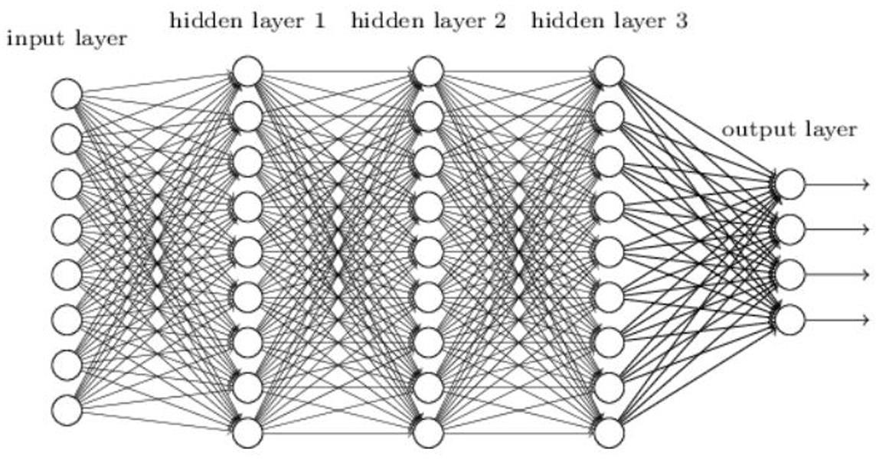

CONVOLUTIONAL LAYERS:

The convolutional layers serve as feature extractors, and thus they learn the feature representations of their input images. The neurons in the convolutional layers are arranged into feature maps.
Each neuron in a feature map has a receptive field, which is connected to a neighbourhood of neurons in the previous layer via a set of trainable

weights, sometimes referred to as a filter bank. Inputs are convolved with the learned weights in order to compute a new feature map, and the convolved results are sent through a nonlinear activation function.
All neurons within a feature map have weights that are constrained to be equal; however, different feature maps within the same convolutional layer have different weights so that several features can be extracted at each location.
As the name implies, the convolutional layer plays a vital role in how CNNs operate. The layers parameters focus around the use of learnable kernels.
These kernels are usually small in spatial dimensionality, but spreads along the entirety of the depth of the input. When the data hits a convolutional layer, the layer convolves each filter across the spatial dimensionality of the input to producea 2D activation map. These activation maps can be visualised.
As we glide through the input, the scalar product is calculated for each value in that kernel. From this the network will learn kernels that ‟fire‟ when they see a specific feature at a given spatial position of the input. These are commonly known as activations.
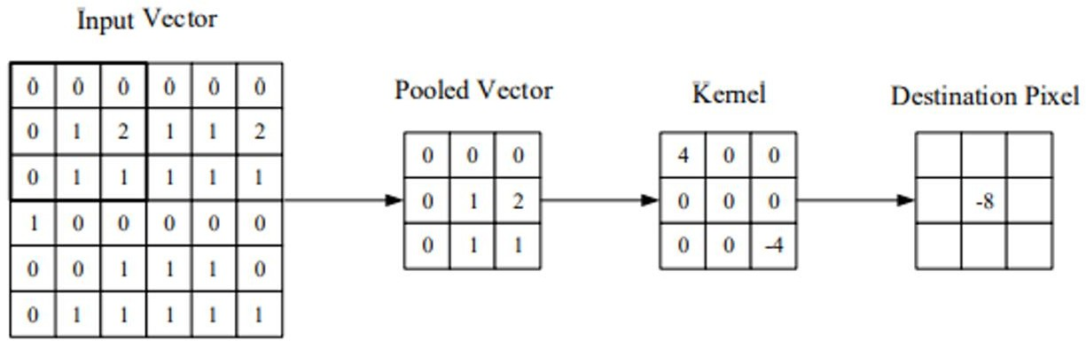

Pooling Layers
The purpose of the pooling layers is to reduce the spatial resolution of the feature maps and thus achieve spatial invariance to input distortions and translations. Initially, it was common practice to use average pooling aggregation layers to propagate the average of all the input values, of a small neighbourhood of an image to the next layer. However, in more recent models, max pooling aggregation layers propagate the maximum value within a receptive field to the next layer. Pooling layers aim to gradually reduce the dimensionality of the representation, and thus further

reduce the number of parameters and the computational complexity of the model.

3.5 Fully Connected Layers
Several convolutional and pooling layers are usually stacked on top of each other to extract more abstract feature representations in moving through the network. The fully connected layers that follow these layers interpret these feature representations and perform the function of high- level reasoning. For classification problems, it is standard to use the SoftMax operator on top of a DCNN. While early success was enjoyed by using radial basis functions (RBFs), as the classifier on top of the convolutional towers found that replacing the SoftMax operator with a support vector machine (SVM) leads to improved classification accuracy. The fully-connected layer contains neurons of which are directly connected to the neurons in the two adjacent layers, without being connected to any layers within them. This is analogous to way that neurons are arranged in traditional forms of ANN.

3.6 Training
CNNs and ANN in general use learning algorithms to adjust their free parameters in order to attain
the desired network output. The most common algorithm used for this purpose is backpropagation.
Backpropagation computes the gradient of an objective function to determine how to adjust a
Network’s parameters in order to minimize errors that affect performance.
A commonly experienced
problem with training CNNs, and in particular DCNNs, is overfitting, which is poor performance on a
held-out test set after the network is trained on a small or even large training set. This affects the
model’s ability to generalize on unseen data and is a major challenge for DCNNs that can be
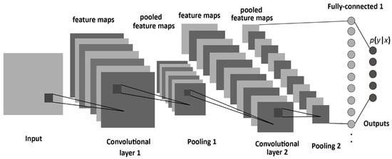
assuaged by regularization.

CHAPTER 4

Project Methodology

Planning
In planning phase study of reliable and effective algorithms is done. On the other hand, data were collected and were pre-processed for more fine and accurate results. Since huge amount of data were needed for better accuracy, we have collected the data surfing the internet. Since, we are new to this project we have decided to use local binary pattern algorithm for feature extraction and support vector machine for training the dataset. We have decided to implement these algorithms by using OpenCV framework.

System Design
System design shows the overall design of system. In this section we discuss in detail the
design aspects of the system:

Fig. System Diagram
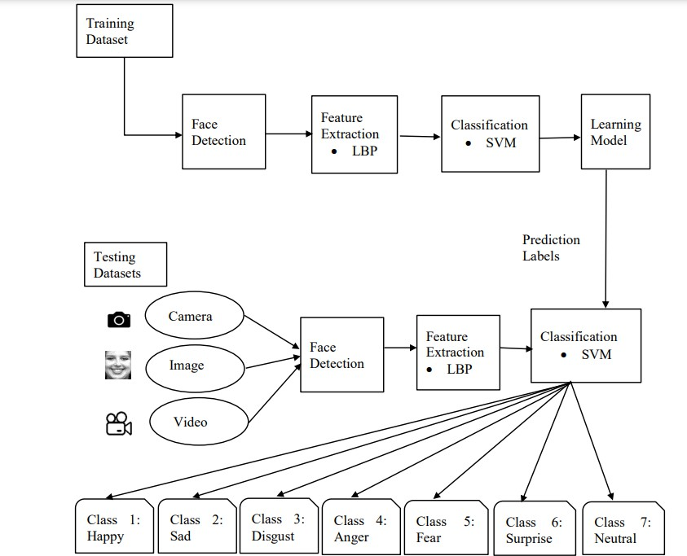

  - Phases in Facial Expression Recognition

The facial expression recognition system is trained using supervised learning approach in which it takes images of different facial expressions. The system includes the training and testing phase followed by image acquisition, face detection, image preprocessing, feature extraction and classification. Face detection and feature extraction are carried out from face images and then classified into six classes belonging to six basic expressions which are outlined below:

Image Acquisition
Images used for facial expression recognition are static images or image sequences. Images of face can be captured using camera.

Face detection
Face Detection is useful in detection of facial image. Face Detection is carried out in training dataset using Haar classifier called Voila-Jones face detector and implemented through OpenCV. Haar like features encodes the difference in average intensity in different parts of the image and consists of black and white connected rectangles in which the value of the feature is the difference of sum of pixel values in black and white regions.

Image Pre-processing
Image pre-processing includes the removal of noise and normalization against the variation of pixel position or brightness. There are three of image processing used. They are
      - Image to Image transformation
      - Image to Information transformations
      - Information to Image transformations
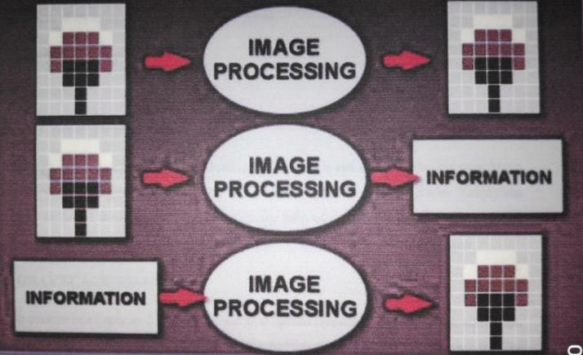

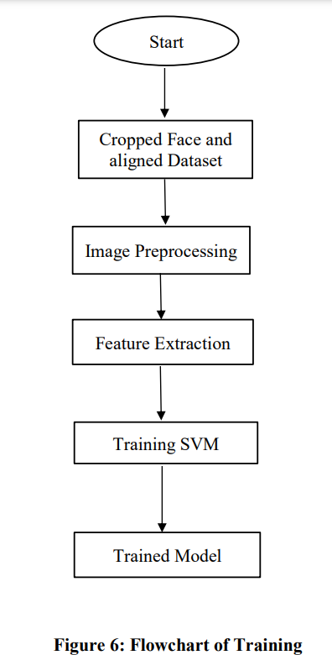

Feature Extraction
Selection of the feature vector is the most important part in a pattern classification problem. The image of face after pre-processing is then used for extracting the important features. The inherent problems related to image classification include the scale, pose, translation and variations in illumination level [6]. The important features are extracted using LBP algorithm which is described below:

Local Binary Pattern

LBP is the feature extraction technique. The original LBP operator points the pixels of an image with decimal numbers, which are called LBPs or LBP codes that encode the local structure around each pixel. Each pixel is compared with its eight neighbours in a 3 X 3 neighbourhood by subtracting the centre pixel value. In the result, negative values are encoded with 0 and the others with 1. For each given pixel, a binary number is obtained by merging all these binary values in a clockwise direction, which starts from the one of its top-left neighbours. The corresponding decimal value of the generated binary number is then used for labelling the given pixel. The derived binary numbers are referred to be the LBPs or LBP code

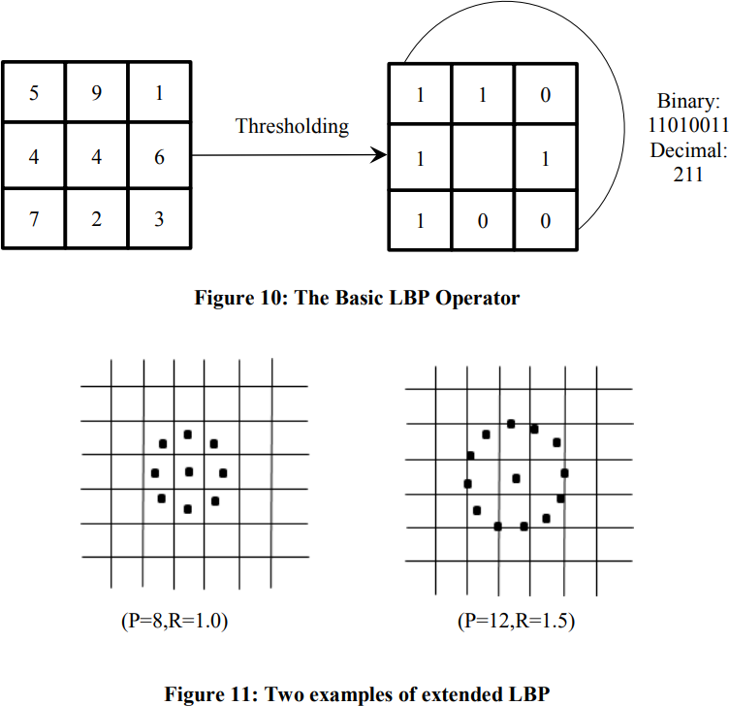

4.4 Data Collection
Dataset is taken from Kaggle.com i.e. Face expression recognition dataset to train the model. In this dataset, around 28k images is present. The dataset consists of images of faces, each labelled with one of seven facial expressions: Angry, Disgust, Fear, Happy, Sad, Surprise, and Neutral. The images are not uniformly sized, and preprocessing will be required to standardize the input for the model.
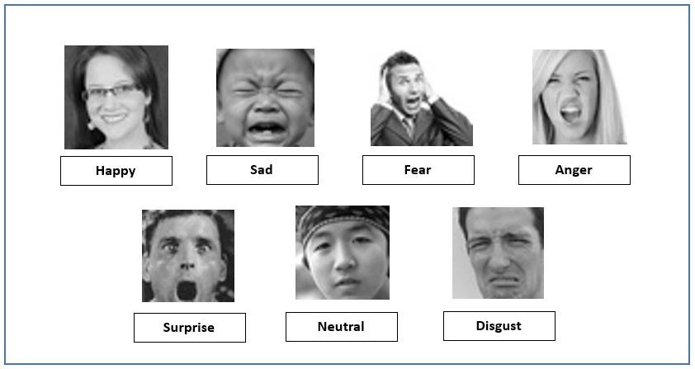

The dataset contains approximately 36,000 images, divided into training and validation sets, with 80% used for training and 20% for validation.

Data Preprocessing and Methods:

- Grayscale Conversion (if needed):
Although the images are currently in colour, converting them to grayscale may simplify computations by reducing the input channels from three (RGB) to one. This step depends on whether the colour information is deemed essential for the recognition task.

Rescaling to Uniform Size:
Since the images are not all 48x48 pixels, we will rescale them to a uniform size (such as 48x48 or another size suitable for the CNN architecture). Rescaling ensures that all images have the same dimensions, which is crucial for batch processing in deep learning models.

Normalization:
The pixel values of the images range from 0 to 255. To standardize the input and facilitate faster and more stable convergence during training, we
will normalize the pixel values to a range between 0 and 1 by dividing each pixel value by 255.

Data Augmentation:
To enhance model generalization and prevent overfitting, data augmentation techniques such as rotation, zoom, shift, horizontal flip, and brightness adjustment will be applied. These transformations create variations in the training images, allowing the model to learn from a more diverse dataset.

Categorical Encoding:
The facial expression labels are currently integers. We will convert these labels into a one-hot encoded format to create a probability distribution output for the seven expression classes, which is more suitable for multi- class classification tasks.

Splitting the Dataset:
Although the dataset is already divided into training and validation sets, further splitting may be done to create a separate test set. This helps evaluate the model's performance on unseen data and ensures it generalizes well beyond the training set.

Batch Processing and Shuffling:
To optimize memory usage and training efficiency, the data will be processed in batches. Additionally, shuffling the training data before each epoch will help prevent the model from learning any specific order in the data, which can improve generalization.

By applying these preprocessing methods, we prepare the dataset for effective training of a convolutional neural network (CNN) model, ensuring it learns to accurately recognize facial expressions from the images provided.

CHAPTER 5

Results Overview
This chapter presents a detailed analysis of the results obtained from our facial recognition convolutional neural network (CNN) model. The evaluation was conducted using Python IDLE and OpenCV to process and visualize the data. We will discuss the methods employed to generate results, present key performance metrics through graphs, and analyse the model's accuracy and loss to understand its effectiveness.

Generating Results Using OpenCV and Python IDLE

    - Setup and Environment Configuration
We conducted our experiments in Python IDLE, utilizing libraries such as TensorFlow, Keras, NumPy, and OpenCV. The Python environment was configured to include all necessary dependencies to ensure smooth execution. The primary steps involved installing Python libraries and
setting up OpenCV for image processing tasks.

Image Preprocessing and Data Augmentation
OpenCV was employed to handle various preprocessing tasks, including:
      - Resizing Images: All images were resized to a uniform size suitable for the CNN model, ensuring consistency in input dimensions.
      - Normalization: Pixel values were normalized to a range between 0 and 1 by dividing by 255, improving the model's learning efficiency.
      - Data Augmentation: Techniques such as rotation, flipping, and zoom were applied to artificially expand the dataset. This helped improve the model's robustness and generalization capabilities.

Visualizing Results with OpenCV
After training the model, OpenCV was used to visualize the predictions on the validation and test datasets. This included:
      - Displaying Predicted vs. Actual Labels: OpenCV functions like cv2.putText and cv2.rectangle were utilized to overlay predicted labels and bounding boxes on the images.
      - Sample Outputs: Sample images were shown with predicted labels to illustrate the model’s performance. We observed that the model

correctly predicted certain expressions while misclassifying others, providing insights into areas for improvement.

Results Graphs: Accuracy and Loss Analysis

    - Training and Validation Accuracy Graphs
The accuracy of the model was tracked over each epoch during training. The graph showed an initial sharp increase in accuracy, which gradually plateaued. Key observations include:
      - Convergence: The model reached a peak training accuracy of around 82%, with validation accuracy following a similar trend but slightly lower, indicating a moderate fit to the training data.
      - Overfitting Signs: The gap between training and validation accuracy suggested the model might be overfitting to some extent. Strategies such as dropout layers or more aggressive regularization could help address this.

Training and Validation Loss Graphs
Loss curves were analysed to understand the optimization process:
      - Loss Reduction: Both training and validation losses decreased initially, but the validation loss started to plateau earlier than the training loss.
      - Stability: The model's loss graphs indicated that while the training loss continued to decrease steadily, the validation loss became erratic, pointing to potential overfitting or issues with model generalization.

Interpretation of Accuracy and Loss
The relationship between accuracy and loss suggests that while the model learns well initially, it struggles to generalize beyond the training data:
      - Training Dynamics: The stable reduction in training loss shows effective learning, but the validation loss behavior indicates overfitting, where the model is learning the noise and specificities of the training data rather than general patterns.

Visualizing OpenCV
In this section, we provide visual evidence of the output generated by our facial expression recognition model using OpenCV. The screenshots illustrate various stages of the model's performance, from initial image processing to final classification results. These images not only demonstrate the practical application of OpenCV in real-time scenarios but also highlight the model's accuracy and effectiveness in recognizing facial expressions

#Graphical Representation of Accuracy and Loss Function

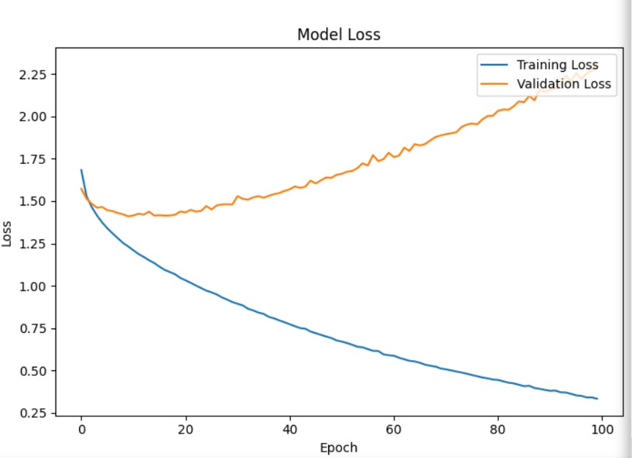
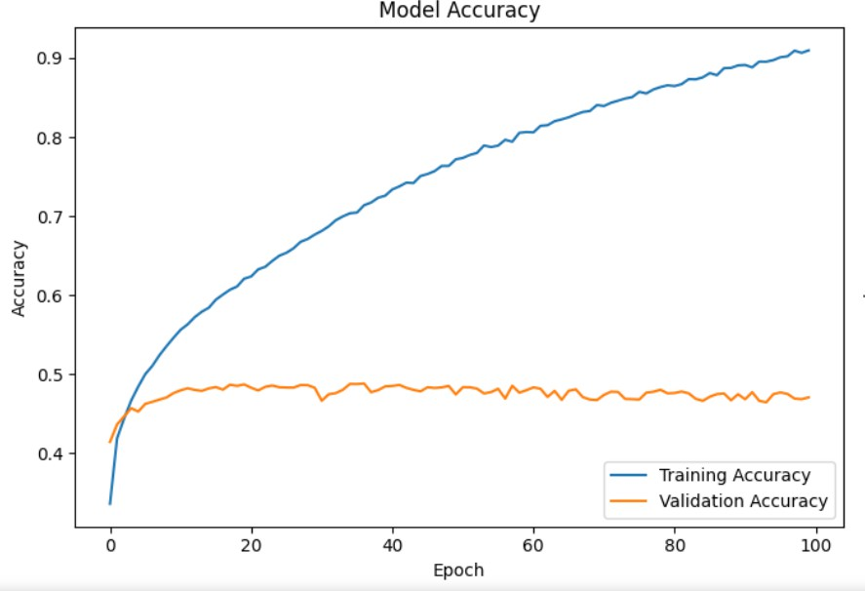

*Note: - The graphs are based on small sample space

Key Findings and Analysis

    - Overall Performance Summary
The model achieved a maximum accuracy of 62%, which is below expectations for a robust facial recognition system. This performance level indicates the need for further optimization:
      - Model Limitations: The moderate performance could be due to the model architecture, insufficient data augmentation, or limited training data.

Error Analysis and Class-Wise Performance
A confusion matrix was generated to evaluate model performance across different classes:
      - Frequent Misclassifications: The model often confused “Sad” with “Neutral” and “Fear” with “Surprise,” suggesting these expressions have similar visual features that the model finds challenging to differentiate.
      - Class Imbalance Impact: Certain classes had fewer samples, which may have skewed the model’s ability to learn and accurately predict those expressions.

Recommendations for Improvement
Based on the results, several strategies could be explored to enhance model performance:
      - Advanced Augmentation: Implementing more sophisticated data augmentation techniques could provide the model with a richer variety of training examples.
      - Model Complexity: Experimenting with deeper architectures or incorporating pre-trained models could improve accuracy.
      - Regularization Techniques: Applying techniques like dropout, L2 regularization, or data augmentation could reduce overfitting.

CHAPTER 6

Conclusion And Future Scope

Concluding Remarks

The rapid advancements in Artificial Intelligence (AI) and Machine Learning (ML) have revolutionized numerous industries, leading to the development of innovative applications such as emotion detection. This technology, a subset of affective computing, allows machines to interpret and respond to human emotions, marking a significant leap in human- computer interaction. Emotion detection enhances user experiences by providing more personalized and empathetic interactions, with broad applications in customer service, education, and healthcare. By improving the ability of machines to understand and adapt to emotional states, emotion detection has the potential to make technology more intuitive and effective, thereby transforming how we interact with digital systems and each other.

Future Scope

    - Advancement of Emotion Detection Technologies: Future research will focus on enhancing the accuracy and functionality of emotion detection models, exploring advanced machine learning techniques such as deep learning and hybrid models to improve precision and broaden the range of detectable emotions.
    - Expansion into New Application Areas: The technology will be applied to new fields such as retail, to tailor customer interactions; entertainment, to customize content based on emotional responses; and the workplace, to monitor and improve employee well-being.
    - Addressing Ethical and Privacy Concerns: There will be a concerted effort to address ethical considerations and privacy issues, developing guidelines and safeguards to ensure the responsible use of emotion detection technologies and protect user data.

    - Integration with Emerging Technologies: Integration with emerging technologies like virtual reality (VR) and augmented reality (AR) will be explored to create immersive and emotionally responsive environments, offering new applications in entertainment, training, and therapy.
    - Industry Collaboration and Commercialization: Collaborations with industry partners will be essential for translating emotion detection technologies into real-world applications, leading to the development of commercial products and driving market adoption.
    - Development of Educational Resources: Educational materials and training programs will be developed to disseminate knowledge and skills related to emotion detection, helping to prepare future researchers and practitioners in the field.
    - Longitudinal Impact Studies: Longitudinal studies will be conducted to evaluate the long-term effects and impacts of emotion detection technologies on human behavior and interactions, providing insights into their effectiveness and any potential challenges.

Table 6.1: User Feedback Table

Feedback Aspect | Ratings | Comments
Ease of Use | 5 | Intuitive & User- Friendly
Accuracy | 4 | Mostly Accurate
Technical Aspects | 3 | Could be improved
Sentiment Analysis | 4 | Useful but need refinement

REFERENCES

- Facial emotion recognition using deep learning: review and insights
By Wafa Mellouk, Wahida Handouzi

- Face expression recognition dataset
By Jonathan Oheix (www.kaggle.com/datasets/jonathanoheix/face-
expression-recognition-dataset)

- Research and Implementation of CNN Based on TensorFlow
By Liang Yu, Binbin Li and Bin Jiao

